Book Summaries

Thanksgiving with the Bully
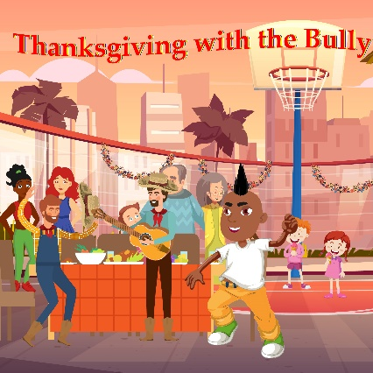
Royal is constantly being picked on and has been called mean names by the new kid Tony. He told his teacher and even the principle to no avail.
With the support of his parents, Royal was able to stand up for himself and confront the bully. Royal felt empowered and victorious, until he got a sneak peak of Tony’s life during Thanksgiving break. Read what happens when Royal discovers the truth about the school bully.
This fictional picture publication was created to help bring awareness to bullying, a nationwide issue that at least one in five students experience.
Thanksgiving with the Bully is great for social emotional learning, building interpersonal relationships, teaching the importance of safety, and can help dismantle the bullying epidemic.
Readers in grades 2nd-4th may benefit best from this book!

You Are: Tu Eres

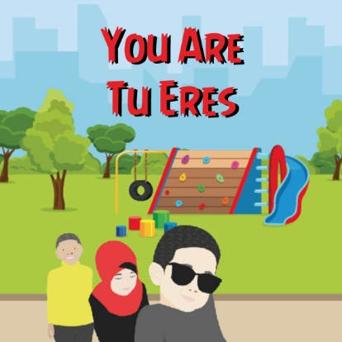

“You are strong. You are important. You are beautiful.”

Although there is no true storyline, You Are: Tu Eres is a simple yet unique picture book that teach young readers the power of positive affirmations. The affirmative words on each page can create a positive self-image and boost self-esteem for the reader and listener. Each page is filled with diverse characters from underrepresented groups like vitiligo, amputees, and other minority groups. This book is also a dual-language publication helping introduce and further expose young readers to a second language.

You Are: Tue Eres is a great introduction to self-esteem building, self-empowerment, and autonomous positive thinking.

This publication is best fit for young reader up until the 2nd grade.

Boy’s Wash Their Hands Too: Los Ninos Tambien Se Lavan Las Manos

Boys have a reputation of being smelly and dirty!
This non-fictional book challenges the gender stereotype about boys and provides a step-by-step tutorial of how to properly hand wash.

“Boys Wash Their Hands Too: Los Ninos Tambiem Se Lavan Las Manos,” is a fun intermediate dual language read with diverse characters young readers
will love!
Despite the title, this publication is perfect for both girl and boy readers.
This publication can be used to encourage youth to practice proper hygiene and is also good for intermediate social emotional learning.
This publication is targeted to 3rd-5th graders.

Wander Long, Wonder Strong

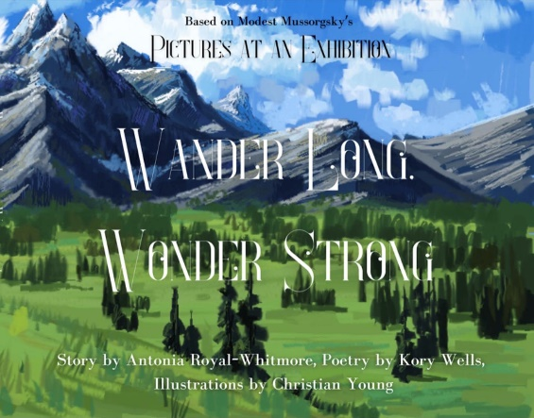

This is the story about Dayo’s mysterious journey with nature, a hint of self-discovery, told poetically.
The name Dayo is an African name meaning ‘joy arrives”. Will Dayo ever experience the joy his name promises?
Wander Long, Wonder Strong is a thought-provoking children’s book with so many twists, turns, and unexpected, events. This book was inspired by The Picture’s at an Exhibition classical music piece.
Best for grades 3rd-5th grade.

